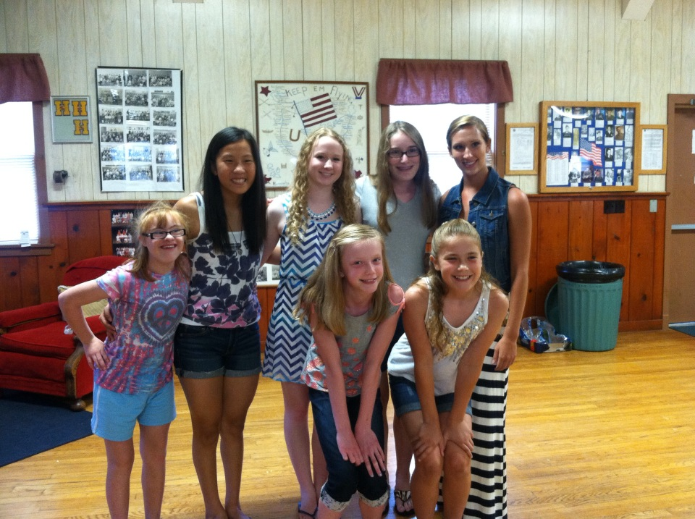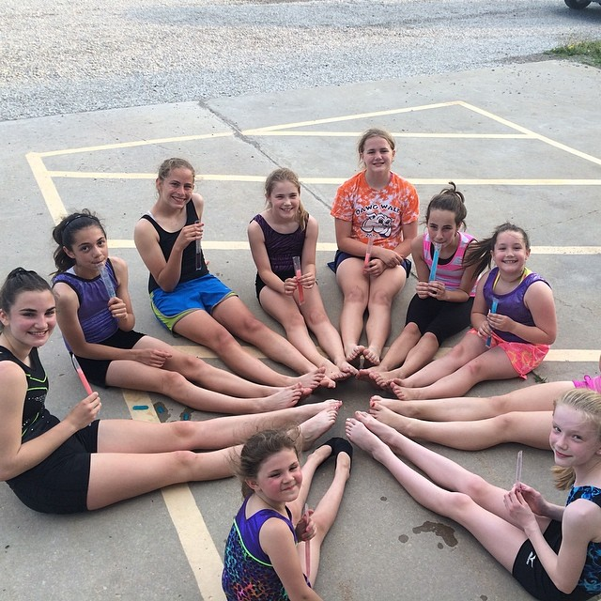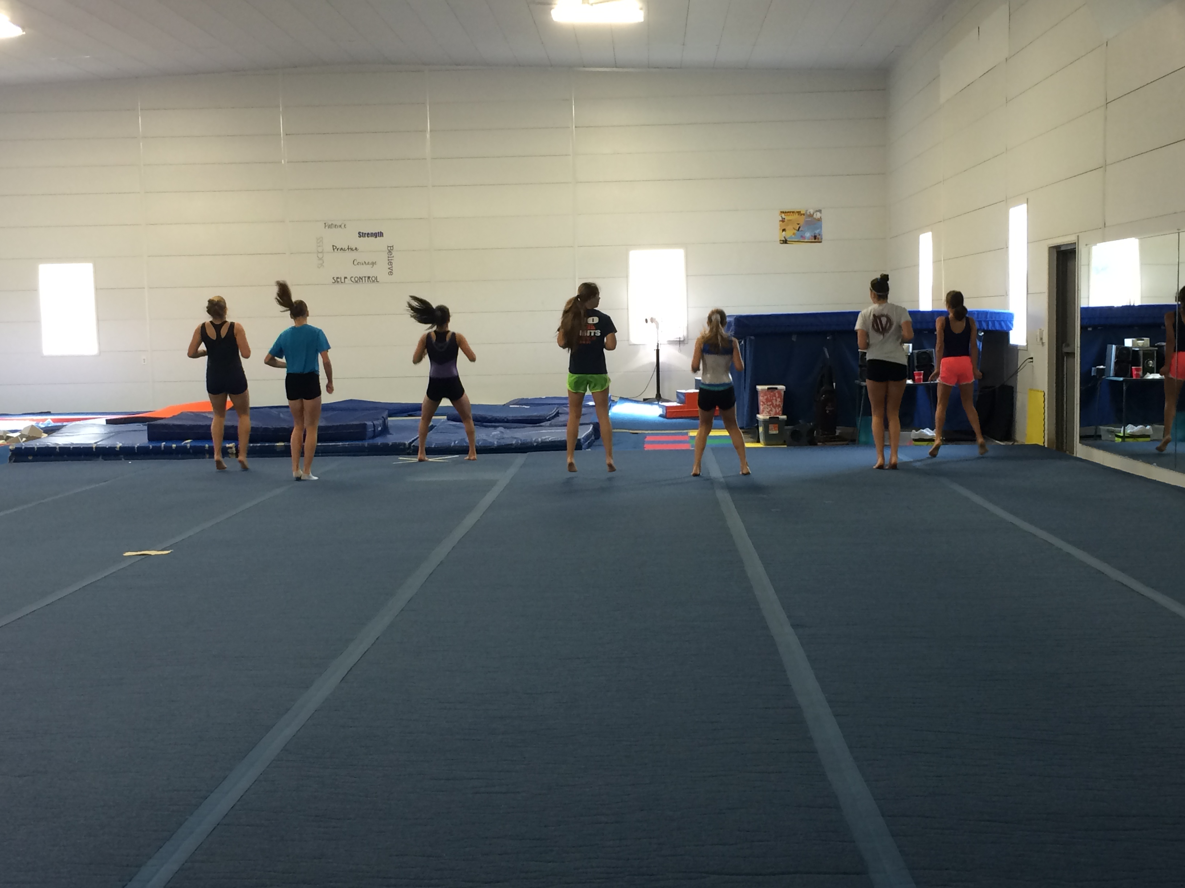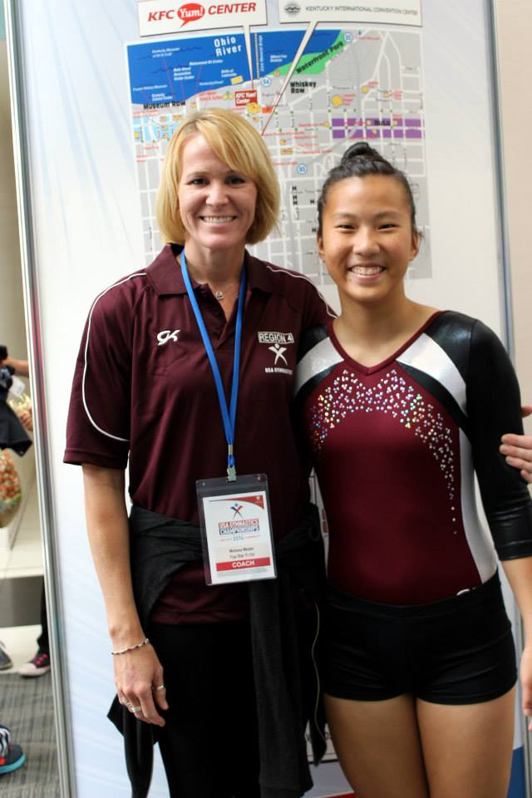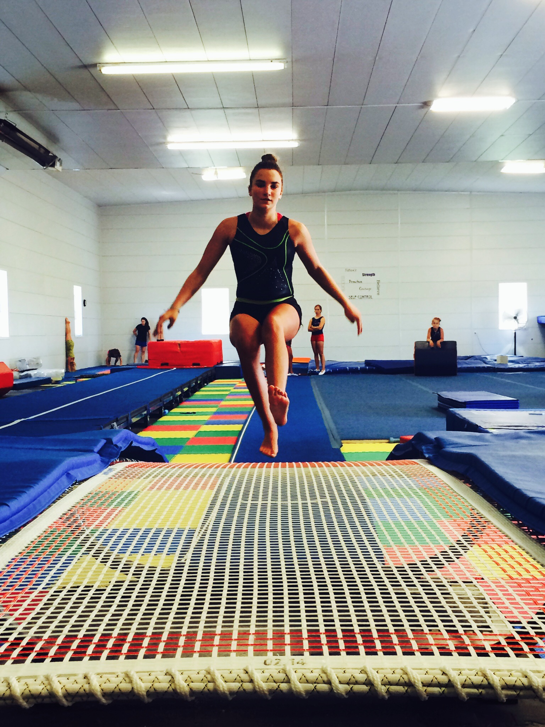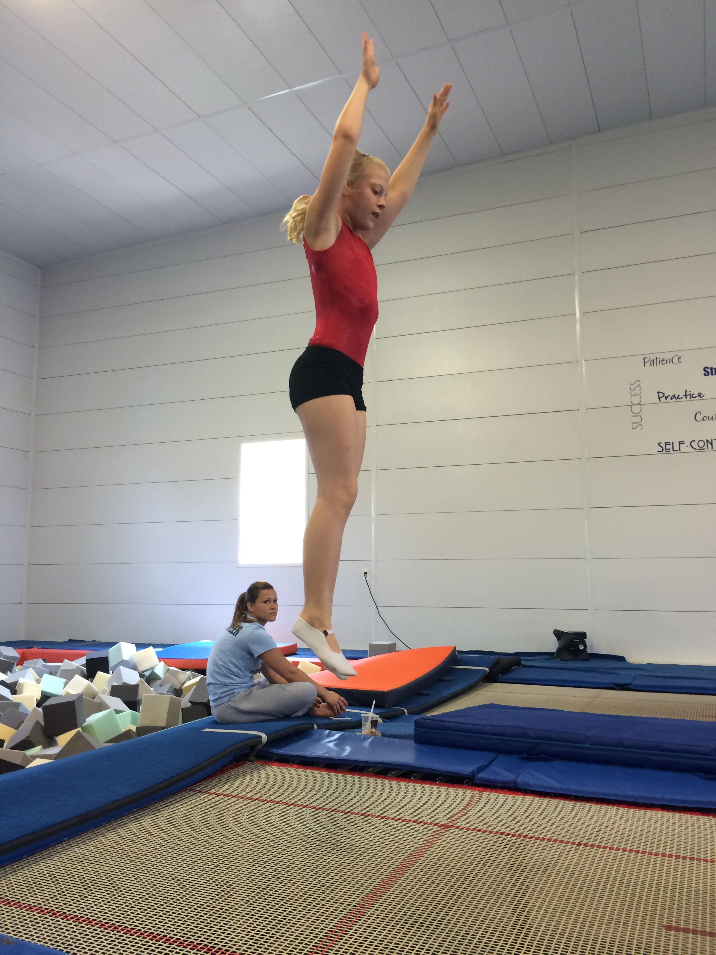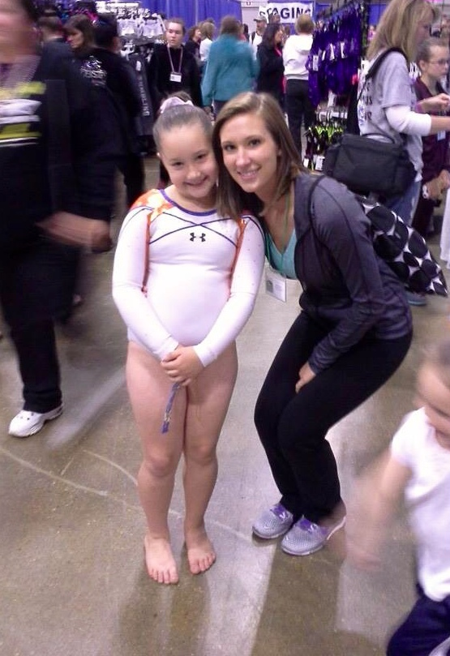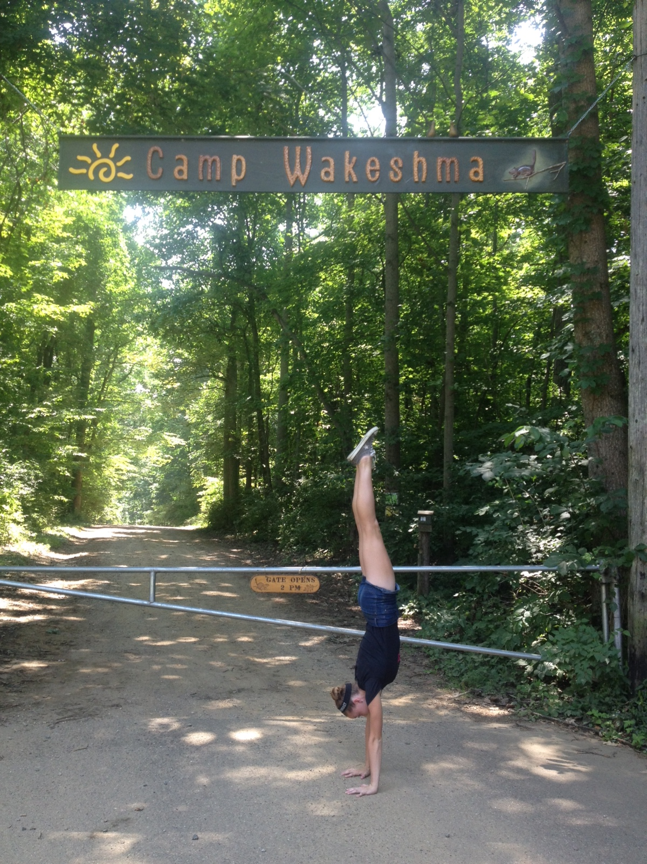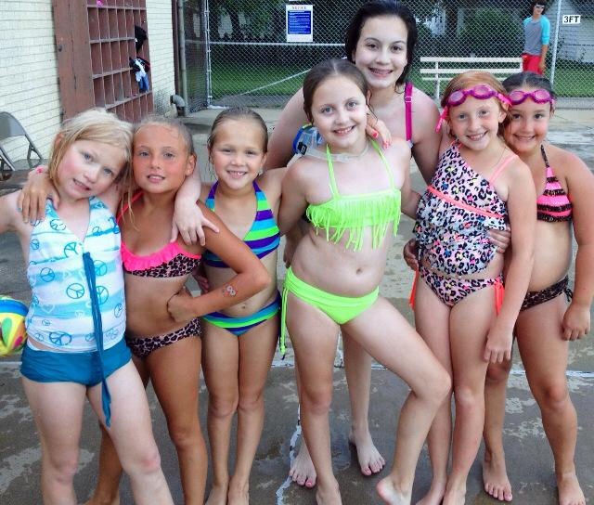

Team Info

Any kids who plan on competing trampoline & tumbling with Top Star in the upcoming season will owe an additional $49 along with the annual registration. This covers USAG fees for the season. Optional competition team classes will be offered during the two weeks that the gym will be closed. There is a sign up on the desk with dates and times listed. Please sign up for the evenings you plan on attending. Please note that these extra practices are for team athletes only! The extra classes will be at an additional cost.

F Y I

Session 3 starts July 28th and goes until Thursday, August 14th. The gym will then be closed for the following two weeks. Fall schedule will begin Tuesday, September 2nd. Registration for fall classes will be August 25th-28th, 4:00-7:00pm in the gym. This is our annual registration period and every child must be re-registered to continue classes at Top Star. The registration fee is $25. If you have enrolled a child and paid the registration fee on or after June 1st, you will only owe a prorated registration fee of $7.

August 2nd: Grace Skube & Sierra Taylor

August 4th: Makenna Fiscus

August 10th: Lizzy Scott

August 13th: Emma Stoerger & Mikayla Johnson

August 17th: Deanna Diesburg

August 19th: Kendra Snelling

August 28th: Shelbee Owens

September Birthdays!

If you see any of these athletes in the gym, be sure to wish them a happy birthday!

## 

August 2014

Top Star Newsletter

Kayla good I Love Top star because coaches you are so nice you help me Love Top Star . ♡

The kids were able to submit a Shout Out to a parent or coach to be published in the August newsletter! So here they are… word for word!

July Competition Results

USAG Nationals – July 15th-19th – Louisville, KY Delaney Walsh: 10th on trampoline & 11th on double mini At nationals, Dee also represented Region 4 on the Regional All Star team for double mini. The team finished in 1st place at the Regional All Star competition!

AAU Junior Olympics – July 23rd-28th – Des Moines, IA Payton Turk: 5th on double mini & 8th on trampoline

Thanks for putting up with me and Thanks for being amazing coachs and teching me everything I know now. To the coaches Love, Grace Skube

All the coaches are so nice and encouraging!!! –Hannah Hong

Thank you coaches for all you do for us kids. You push us to our limit and love us even when we don’t appreciate it. ♡U -All the kids

Thank you Mami for always taking me to practice and encouraging me to work harder ~Brisa

It’s always nice to come to the gym, because even when it’s hard or you’re struggling, the coaches are always there for you. So, it’s always refreshing to come back and try again. :) -Paige

Name: Ava To: mom, Dad, and coaches. and my brother, and cat. 1. Mom you are the best mom and I will not want a nother. 2. Dad I Love you the same as you love me. 3. Coaches you are the best coaches in the world. 4. brother, David you are the nice One in the world asa brother. 5. cat you are the meawiest of all cats.

Thank you mom for continuing to bring me to practice even though we drove into a ditch the first time we came :) I love you and thank you for supporting me all these years! –Beth♡

Thank you to all of my coaches for always being encouraging and helpful! I love having such WONDERFUL coaches! love, Bri

Mom, Thanks so much for taking the time to drive me to practice and for always supporting me at the practices and meets! ~Meredith H.

Shout out from the kids!

Top Star 1st Place

Raea is the daughter of Top Star’s owner, Missy Weder. It is safe to say that Raea has spent her entire life in the gym and refers to it as her second home! Raea started gymnastics when she was 3 years old and switched over to trampoline and tumbling a couple of years later. She competed trampoline and double mini until she was 14. Raea has been teaching classes at Top Star for three or four years now. She loves coaching double mini and her calm temperament and patient personality makes her great with younger kids! She was also a part of Top Star’s competitive cheer program for 5 years! Raea was on her school’s competitive dance team for 3 years and is nothing short of talented! She recently graduated from Mattoon High School with honors and in the top 10% of her class! She was accepted into Parkland College’s veterinary technology program and will begin her college career this fall!

Meet the Coach! Raea Weder – T&T coach



From me to all of you:

I’m going to take advantage of being the one who writes the newsletters by adding a section a little more personal than the rest. As many of you know, my time at Top Star is coming to a close, hopefully not permanently, but at least for the next few years. I have no words to describe the ways your children have impacted my life. I often find myself rambling on about my “awesome kids” to people who have no idea who I am talking about… and probably don’t care! But I can’t help it, coaching tumbling is what I love to do and I can’t imagine my life without this sport. So I want to say a huge thank you to all of the parents who have raised the wonderfully loving kids that make me tear up when I think about leaving them. Parents, all I ask is that you keep encouraging your children and remind them that they have coaches that love them to the moon and back!

Thank you,

Erin Turner

**Top Star Training Center**

1708 W. Hensley Rd

217-378-5058

topstargym.net

topstargym@hotmail.com

#### We are so proud of our athletes, parents and coaches. Thank you for your dedication, loyalty, and support in helping us create a successful and confident family atmosphere.

Top Star is hosting a cheerleading camp for all ages and skill levels! The camp is on Saturday, August 23rd from 10am to 3pm. The cost is $35 per child. A pizza lunch will be provided but please bring your own water bottle. Form fitting, practice appropriate apparel as well as tennis shoes are required. Please have hair pulled back tightly and leave jewelry at home.

#### Top Star Cheer Camp!

Not enough families were able to make our previously scheduled competition team pictures. We felt that it would be a waste if our whole team were not included in the photo. Photos have been rescheduled for September 20th. Details to come.

#### Pictures have been rescheduled!

Unfortunately, our coach’s schedules are just too busy with back to school activities to host a pizza party this month. However, we will have a big “Back to School” pizza party bash in September. So keep your eyes peeled for next month’s sign up! It will be fun!

#### No August Pizza Party